**// Subroutine : UpdateButtonClick_CONTRAST_PLACKET_INNER()**

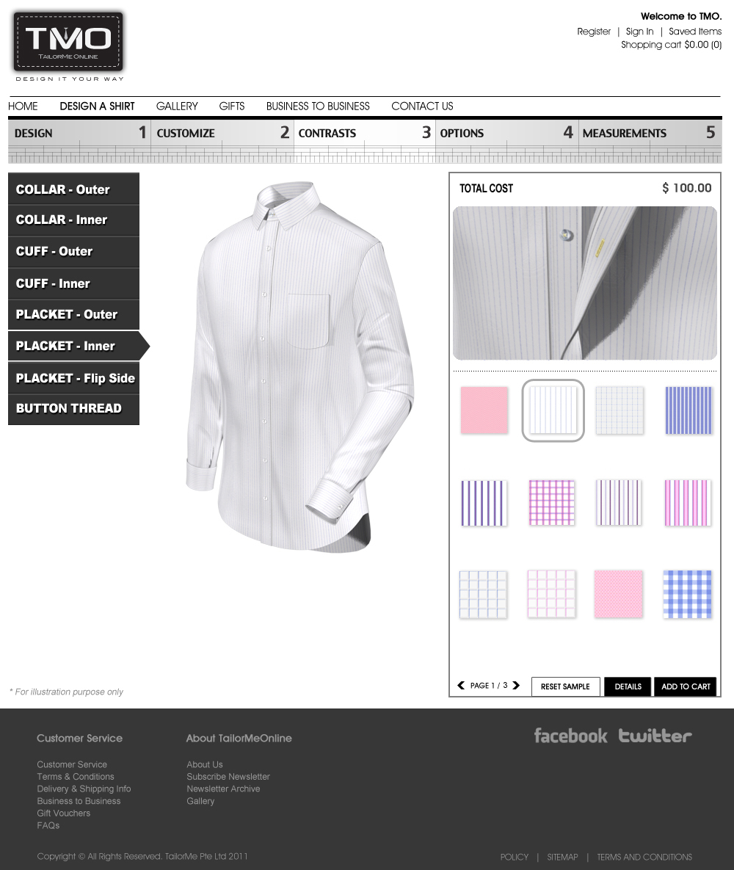

Upon clicking the any fabric button:

// Note : Number the fabric icon in running number from 0001 onwards (ie. 0001, 0002, … , 0031)

PlacketContrastLyr02[4] = ConvertToString(Icon Number);

Call Subroutine : RefreshFilenames();

Call Subroutine : DisplayPlacketContrast(); // This updates the placket contrast window

**// End of Subroutine : UpdateButtonClick_ CONTRAST_ PLACKET_INNER()**